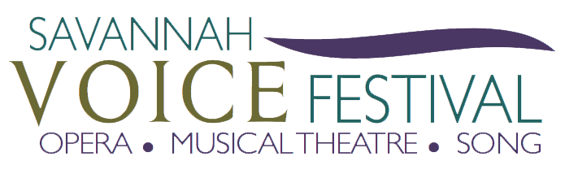
SAVANNAH VOICE FESTIVAL PARTNERS WITH HILTON HEAD SYMPHONY ORCHESTRA TO HOST “VOICES UNDER THE STARS” FREE CONCERT ON TUESDAY AUGUST 15, 2023
SAVANNAH, GA – June 8, 2023 – The Savannah VOICE Festival (SVF), now in its eleventh season, which will run from August 6-20 and is themed “A Lasting Legacy”, has partnered with the Hilton Head Symphony Orchestra to expand the Festival to the Low Country. SVF and the Hilton Head Symphony orchestra will host a free outdoor park concert fearing favorite arias and show tunes al fresco on Tuesday August 15 at 7:30 p.m. at Lowcountry Celebration Park, located at 94 Pope Ave. Hilton Head Island, SC.

“We are so fortunate and excited to partner with Hilton Head Symphony Orchestra to create a program for the community to enjoy,” said Executive Director Chad Sonka. “This is a wonderful opportunity for our Festival to reach new audiences in partnership with other local music organizations in the shared goal of promoting all forms of music.”
During this free event, attendees are encouraged to pack a picnic and enjoy beautiful arias and show tunes performed by Savannah VOICE Festival artists alongside the Hilton Head Symphony Orchestra. Everyone will be able to enjoy their favorite type of music as the Festival celebrates the diversity of voices and origins of the varied repertoires. This collaboration is a part of the larger Savannah VOICE Festival, dedicated to celebrating the beauty of the human voice through opera productions, recitals, concerts, musical theatre and song during this eleventh season at various venues around The Hostess City. This season’s theme of “A Lasting Legacy”, honors the artistic legacy of the Milnes VOICE Programs, and in particular the commitment made by Sherrill Milnes and Maria Zouves to teaching and nurturing the next generation of opera singers.

Tickets go on sale on June 23, but if you would like to support the nonprofit organization and enjoy VIP benefits, you can buy tickets as early as June 16 by becoming a MVP.
For a full line up of the Festival and information about becoming a MVP please visit www.savannahvoicefestival.org, call 855.766.7372 or email info@savannahvoicefestival.org
Savannah VOICE Festival is a 501(c) 3 tax exempt nonprofit arts organization in the state of Georgia. The Festival brings classical vocal excellence to the Savannah area through a two-week celebration of concerts, events and educational presentations during the month of August and throughout the year. Focusing on arts awareness and audience development in the performing arts, it offers music from opera, musical theatre and popular song. Donations are tax-deductible.
The Savannah VOICE Festival is supported in part by the Georgia Council for the Arts through the appropriations from the Georgia General Assembly. GCA is a Partner Agency of the National Endowment for the Arts.
– ENDS –
For media inquiries, please contact Kristyn Beasley at 229-393-6457 or kristyn@lesleyfrancispr.com, Lesley Francis at 912-429-3950 or lesley@lesleyfrancispr.com, or the team at 912-417-LFPR (5377).

