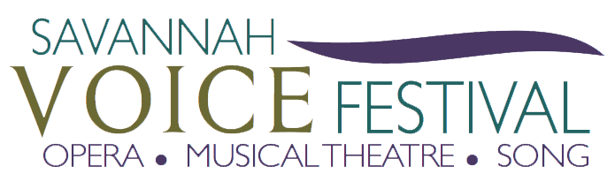
SAVANNAH VOICE FESTIVAL UNVEILS EXCITING LINEUP FOR ELEVENTH SEASON “A LASTING LEGACY” – AUGUST 6- 20, 2023 – TICKETS ON SALE JUNE 23
SAVANNAH, GA – June 8, 2023 – The Savannah VOICE Festival celebrates the beauty of the human voice through opera productions, recitals, concerts, musical theatre and song during this eleventh season, which will run from August 6-20, at various venues around The Hostess City. Everyone will be able to enjoy their favorite type of music as the Festival celebrates the diversity of voices and origins of the varied repertoires. This season’s theme is centered around “A Lasting Legacy”, honoring the artistic legacy of the Milnes VOICE Programs, and in particular the commitment made by Sherrill Milnes and Maria Zouves to teaching and nurturing the next generation of opera singers.

Savannah OPERA will offer three productions as part of the Savannah VOICE Festival. Purcell’s Dido and Aeneas is the first to be performed at the Telfair Museum on Thursday, August 10, followed by Mozart’s Don Giovanni on Saturday, August 12 at Asbury Memorial Church, with Puccini’s Madama Butterfly on Saturday, August 19 at Savannah’s Cultural Arts Center. Artists from the Tokyo International Vocal Arts Academy, founded by SVF’s Artistic Director, Jorge Parodi, will be flying to Savannah to perform in this iconic tragic opera. Long time Festival artist, and former star of Broadway’s Phantom of the Opera, Carlton Moe, returns to the Hostess City for a concert at the Charles H. Morris Center on Wednesday, August 16.
The Festival will provide musical experiences for all to enjoy, with a diverse range of musical performances in exciting venues for attendees to enjoy. This year SVF is expanding to new venues to cover the Coastal Empire and Low Country. For the first time there will be a performance at The National Museum of the Mighty Eighth Air Force in Pooler on Friday, August 11 with the Elite Party Band. SVF Singers will join with these artists to celebrate post-World War II era music. The festival will also branch out to Hilton Head Island in partnership with the Hilton Head Symphony Orchestra for a free outdoor park concert featuring memorable arias and show tunes al fresco. Another collaborative event will take place at Savannah’s De Soto Hotel for a stunning finale and cocktail party when SVF is joined by The Fabulous Equinox Orchestra on the evening of Sunday, August 20th. Other highlights for 2023 include recitals, movie nights, concerts, receptions and more.
Sherrill Milnes said. “We continue to innovate with exciting new productions as well as Festival favorites such as the sacred concert, coffee concerts, and Masters in VOICE master class series.”
Tickets go on sale on June 23, but if you would like to support the nonprofit organization and enjoy VIP benefits, you can buy tickets as early as June 16 by becoming MVP. For a full line up of the Festival and information about becoming a VIP please visit www.savannahvoicefestival.org, call 855.766.7372 or email info@savannahvoicefestival.org
Savannah VOICE Festival is a 501(c) 3 tax exempt nonprofit arts organization in the state of Georgia. The Festival brings classical vocal excellence to the Savannah area through a two-week celebration of concerts, events and educational presentations during the month of August and throughout the year. Focusing on arts awareness and audience development in the performing arts, it offers music from opera, musical theatre and popular song. Donations are tax-deductible.
The Savannah VOICE Festival is supported in part by the Georgia Council for the Arts through the appropriations from the Georgia General Assembly. GCA is a Partner Agency of the National Endowment for the Arts.
– ENDS –
For media inquiries, please contact Kristyn Beasley at 229-393-6457 or kristyn@lesleyfrancispr.com, Lesley Francis at 912-429-3950 or lesley@lesleyfrancispr.com, or the team at 912-417-LFPR (5377).

